Hierarchy: ChessPiece, Pawn, Rook, Knight, Bishop, Queen, King

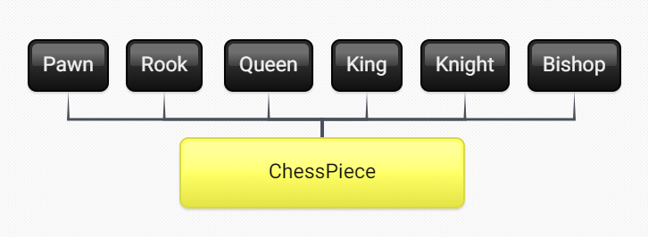

Common Responsibilities:

getPosition();

getColor();

isValidPosition();

setPosition(String p);

canMoveTo();

Overridden:

canMoveTo();

* Pawns can move forward one space at a time, two if it is in it’s starting position
* Rooks can move anywhere along straight lines drawn from it’s current position
* Bishops can move Diagonally from it’s current position
* Queens can move with the combined force of Rooks and Bishops
* Knights can move to positions that are 2 then 1 spaces away, in an L shape
* Kings can over only 1 space all around them.